REST API Usage Plan and API Key Throttling

1. Open API Gateway and select a REST API
2. On the left pane click “Usage Plans”
3. Click “Create”
4. Under Throttling configure Rate and Burst limits

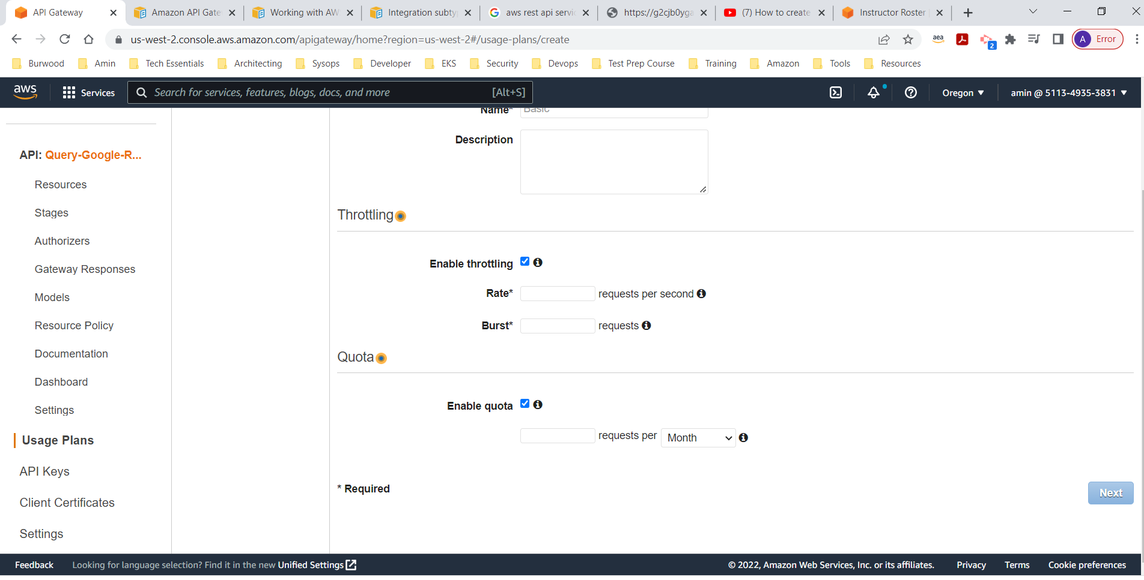

1. After filling out the details click next
2. Specify an API, Stage and configure method throttling

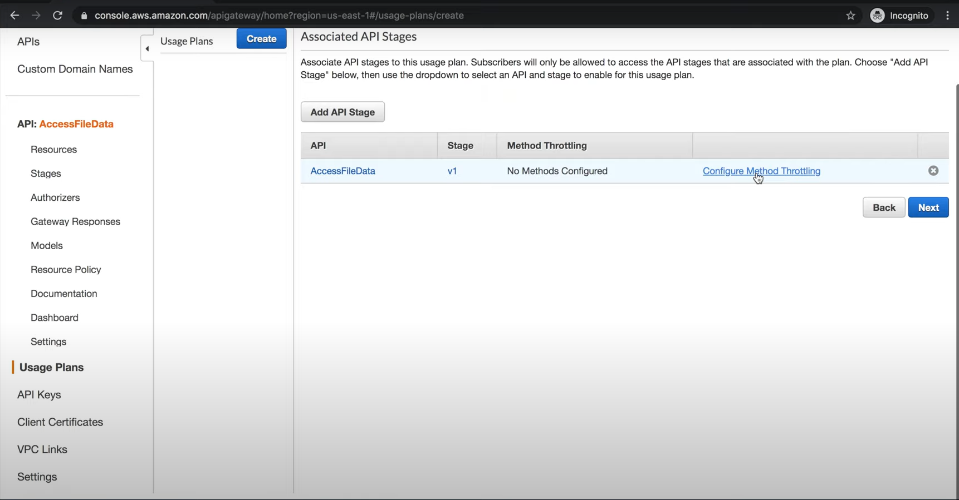

1. Define your resource and method and configure rate and burst limits

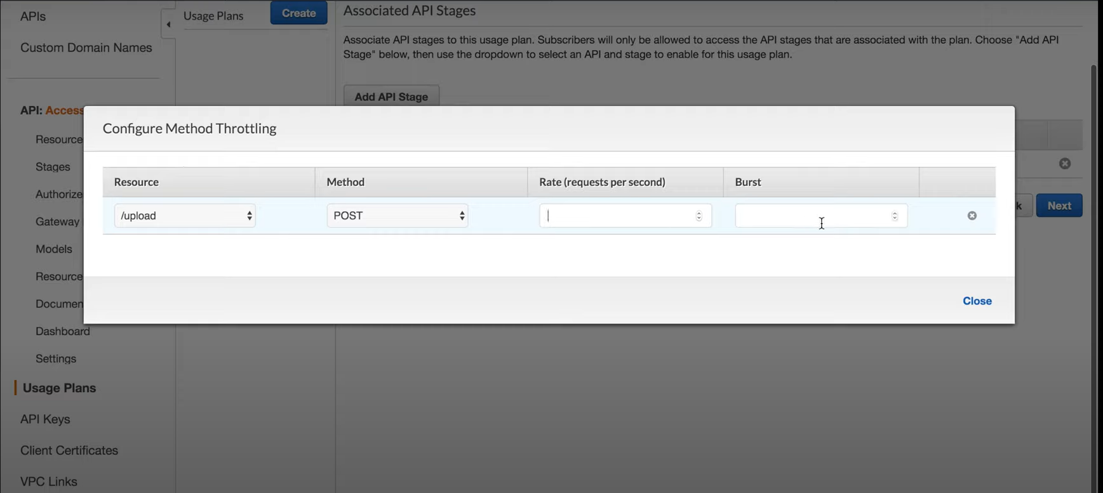

1. Create API Key and add to the usage plan.

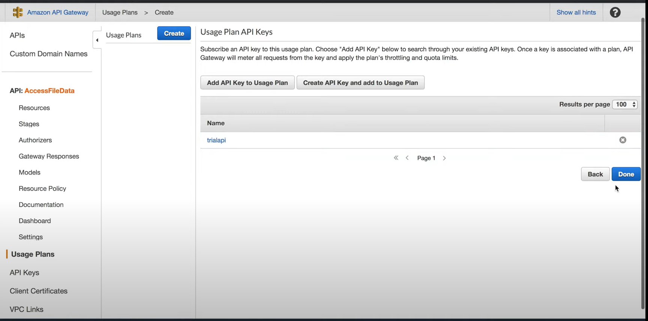

Now that we have an API key we can force all the requests to use the key if they want to send a request to the API.

1. Click on stages and copy the invocation url
2. Open Postman and select a workspace. On the right pane click the “+” sign and create an untitled get request.
3. Paste the invocation URL in the box and click send. We can see that we receive a successful response.
4. Now open the REST API, and click on “Resources” on the left and click on “Get” on the right.
5. Click method request and change “API key required to true”.
6. Deploy the API b y opening actions and clicking “Deploy API”
7. Now if we run postman again we get “Message: Forbidden” response

Now that the API key is required, we will not see a successful 200 response back until we provide the key.

1. Open the API gateway again and select settings from the left.

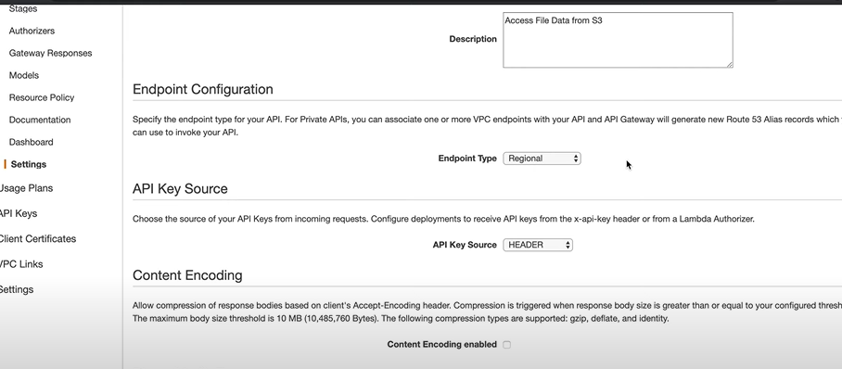

We can see under the API Key Source section that the key name is “x-api-key” in the header

1. Open postman again, select the “Headers” tab. Use the a-apikey name and then paste the key value from the API after clicking “API Key”, and you will get a response back.

